SAVEETHA SCHOOL OF ENGINEERING
SAVEETHA INSTITUTE OF MEDICAL AND TECHNICAL SCIENCES
COMPUTER SCIENCE AND ENGINEERING PROGRAMME
CSA04 – OPERATING SYSTEMS
Name: sanjay.s
Reg no: 192521026

LIST OF PROGRAMS

1. Create a new process by invoking the appropriate system call. Get the process identifier of the
currently running process and its respective parent using system calls and display the same
using a C program.

Program:
#include <stdio.h>
#include <unistd.h>
int main() {
printf("process ID: %d\n", getpid());
printf("parent process id: %d\n",getpid());

return 0;
}
Output screenshot:
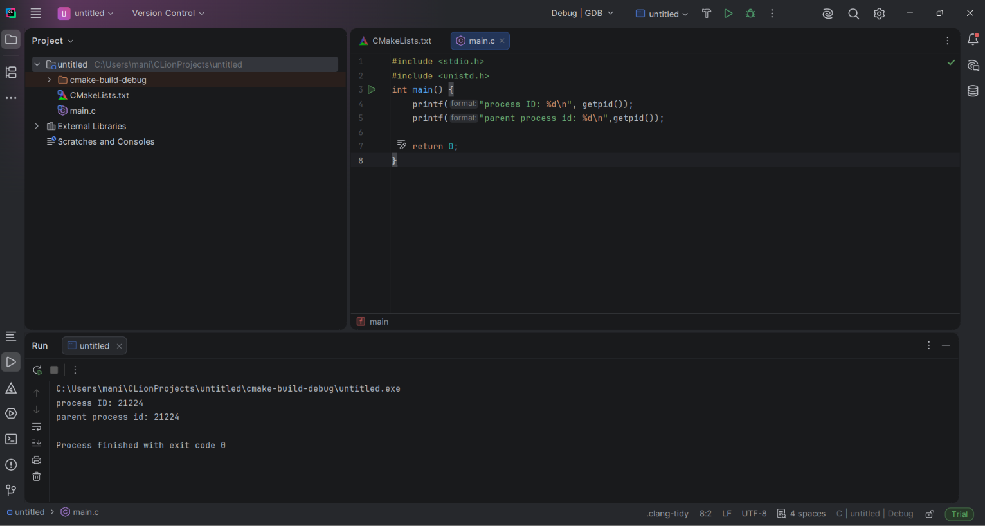
2. Identify the system calls to copy the content of one file to another and illustrate the same using
a C program.

Program:
#include <stdio.h>
#include <stdlib.h>

int main()
{
FILE *fptr1, *fptr2;
char filename[100], c;

printf("Enter the filename to open for reading: ");
scanf("%s", filename);

fptr1 = fopen(filename, "r");

if (fptr1 == NULL)
{
printf("Cannot open file %s\n", filename);
exit(0);
}

printf("Enter the filename to open for writing: ");
scanf("%s", filename);

fptr2 = fopen(filename, "w");

if (fptr2 == NULL)
{
printf("Cannot open file %s\n", filename);
exit(0);
}

c = fgetc(fptr1);

while (c != EOF)
{
fputc(c, fptr2);
c = fgetc(fptr1);
}

printf("\nContents copied to %s\n", filename);

fclose(fptr1);
fclose(fptr2);

return 0;
}
Output screenshot:
